1. 
2. 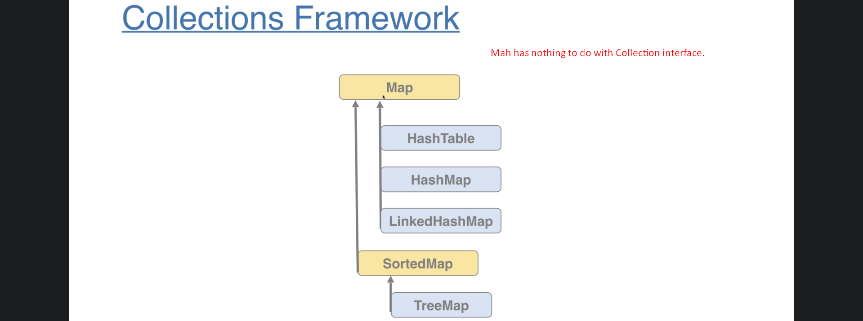

|  |  |
| --- | --- |
| Collection | Map |
| We can store scalar values such as Integer, double, custom class object | We can store key-values. |

1. 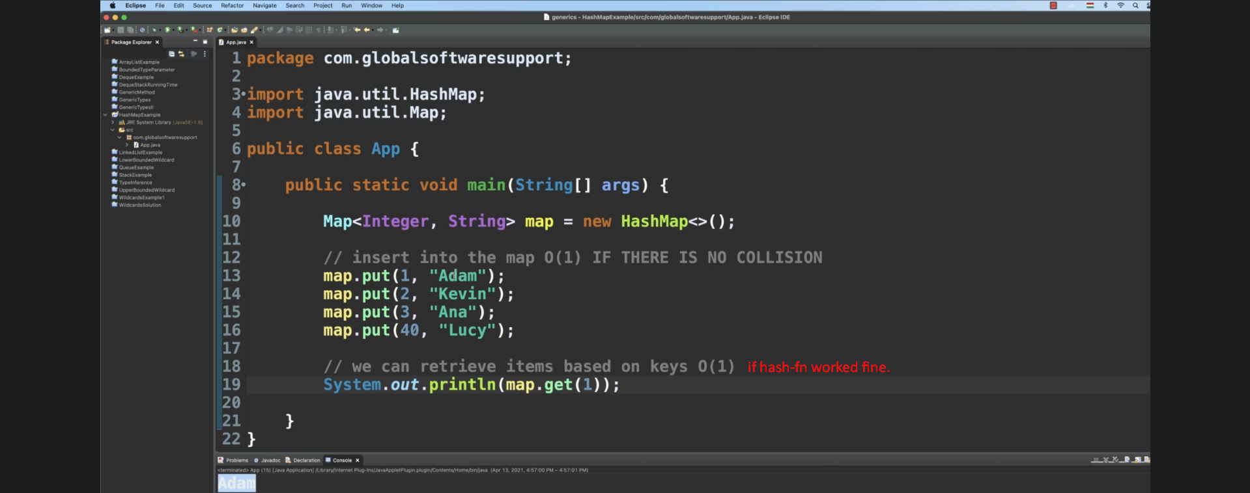
2. 
3. 
4. 